Configure the following scenario using CLI of cisco packet tracer and paste here, the screenshots of your completed task.

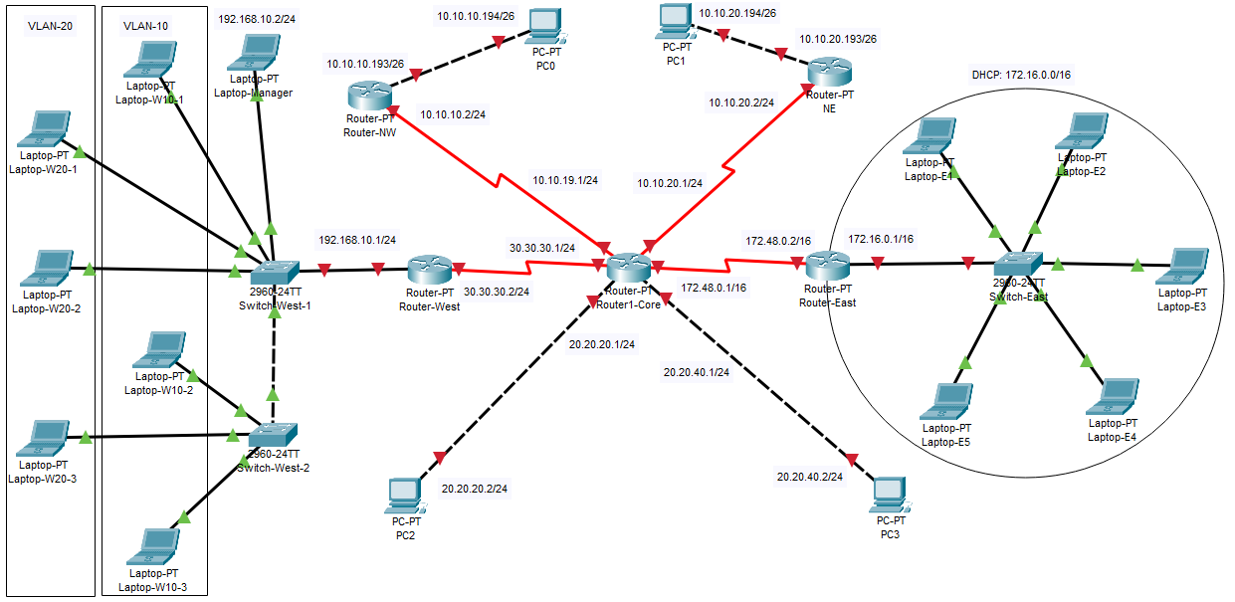

**Instructions:**

1. **All routers are PT-Router and switches are 2960 (Note: add 2 Modules of PT-ROUTER-NM-1S in Router-Core).**
2. **Select and configure all the interfaces according to the given topology and IP Addresses**
3. **Static Routes should be configured at each router so that every PC can connect to any other PCs and laptops.**
4. **Configure VLAN 10 and VLAN 20 on the switches (Switch-West-1 and Switch-West-2).**
5. **Ping from Laptop-Manager to Laptop-E4 and PC0 to PC1, PC2, and PC3.**
6. **Save your topology (along with Routers configuration) in a cisco packet tracer file.**

*Note:*

1. *Each routers and switches hostname should be Your name*

**2- Must Ping/Messages between devices**